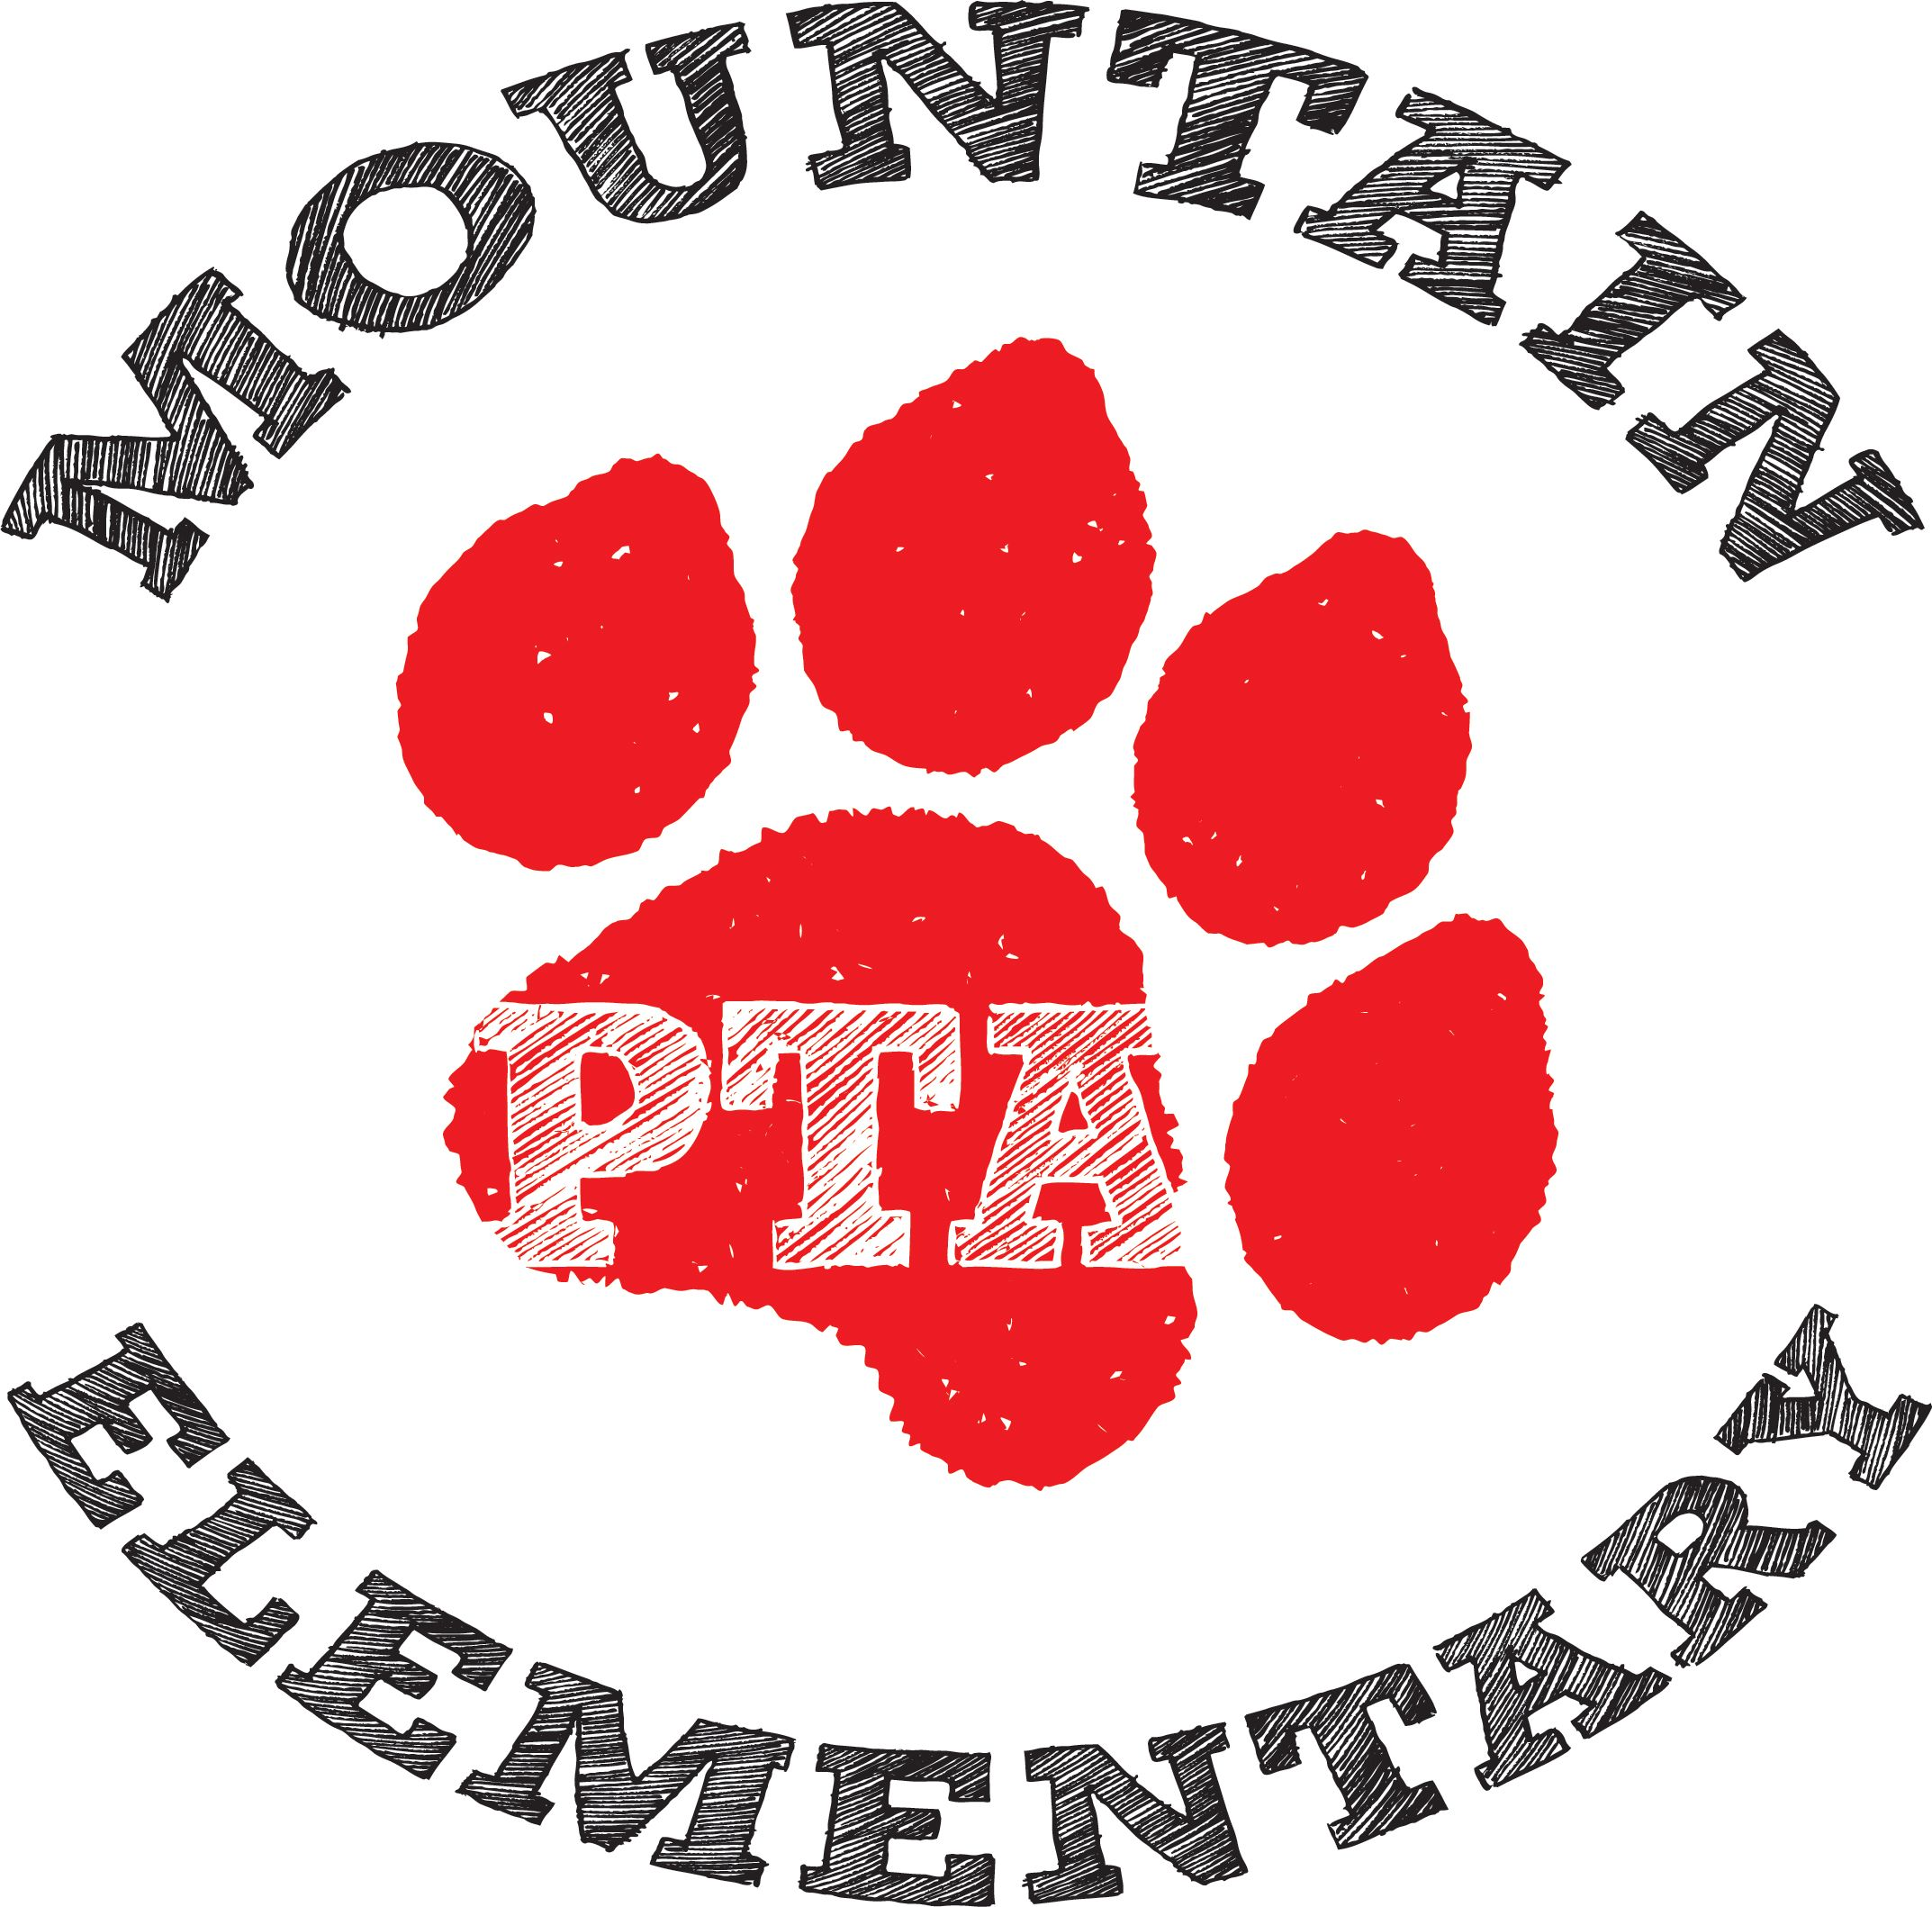

PTA Member Meeting, March 1st, 2021

Meeting called to order by Esther at 7:01 p.m.

Minutes from February 1st meeting approved. Lissie motions to approve. Liz seconds.

Reports of Officers
- Treasurer’s Report –
  - We are a bit over on expenditures, but for the most part we are staying within the amount we have earned this year from Fund Run and LANL Giving. Liz asks for Mad Money to be turned in by May 1st.
  - Allocate money for 6th grade signs again this year. Last year 70 signs were ordered costing $303 total. We have about 90 students this year. Brittany motions to move reading night money to graduation signs. Lissie seconds.
  - Grants need to be turned in before April 31st. Motion to move $1000 5th grade winter activity to educational grants. Ramey motions, Mhairi seconds. Motion was approved.
- President’s Report – We have ordered adult hoodies. Ordered a few extra for a price break beyond what was requested from the preorder. First Day School Supplies will include a $2.00/kit ordered fundraiser. Some youth hoodies are still available for sale. Membership has stayed the same.
- Principle’s Report – The next event will be parent/teacher conferences. PTA will do snacks for teachers. Esther mentioned that a signup Genius will go out this week to organize snacks. Putting out signs showing support and love for the teachers last time was appreciated. Looking at staffing for next year. We’re assuming everyone is coming back in person in the fall. Registration was delayed because of tech difficulties. Ask everyone just keep trying.
- Grant Requests:
  - Taylor SLP for a virtual conference to help with a new $600-$850 amount requested. Lissie motions to approve $660. Natalie seconds.
  - Band teacher $250 band try-out kits. Students can try out instruments. She’s requesting 5-6 kits $40/each. Move club money to Educational Grants. Liz motions for both. Lissie seconds for both.
- Announcements:
  - Signs for 6th graders like last year. Teacher lunches will be a snack bar this year for parent/teacher conf. Yearbooks are all ordered online this year. Dyslexia task force – will be having a speaker on April 12th, 4:30 – 6:30.

Meeting adjoined at 7:41.

Attendees:
Esther Smidt
Elizabeth Daly
Natalie Morgan
Brittany Vollans
Lissie Ham
Mhairi McKay
Olivia Forbes
Ramey Salaz

